James Russo

Math Seminar

Professor Simons

April 6th, 2021

**There’s a GameStop on the Moon Now Apparently**

**Abstract**

The GameStop ($GME) short squeeze defies all known economic and financial conventions. The recent surge of $GME, driven by retail investors, in recent months has been at the center of the financial world. As of now, billions of dollars have been lost by established investors due to constant margin calls in response of the surging of $GME. The purpose of this paper is to explore the background, cause, and mathematical context behind the GameStop short squeeze. Specifically, through showing how the recent surge in $GME is not rotted in the Efficient Market Hypothesis nor the Dividend Discount Model (DDM), a pricing scheme for stocks. What a short squeeze is and how shorting, a financial strategy, contributed to the most recent financial squeeze and how retail investors made millions of dollars through Option Calls. For the purpose of this paper, it will be assumed that the read possess rudimentary mathematical knowledge and no financial knowledge at all. The context of this paper will show that, while the dynamics of the recent GameStop short squeeze are complex and difficult to describe through traditional thought, this was ultimately a tale that can be, and will be told through numbers for years to come.

**Introduction**

In January 2021, Citron Research, ran by famed and active short sell, Andrew Left, announced on Twitter that it would be hosting a livestream event laying out the short case again GameStop. The livestream was meant to argue the idea that people buying GameStop ($GME) stock were “suckers at this poker game,” and according to their own data, Citron claimed its models were currently predicting GameStop shares would go back to $20 (in mid-January it was trading actively at around $40 a share). Flash back several months to an individual named Keith Gill who made a post on a Reddit subreddit called r/WallStreetBets making note of the fact that GameStop was currently being shorted at 140% by Hedge Funds. This led Gill to believe in the notion that GameStop was being undervalued by Wall Street investors and was bound for a climb, leading him to invest his life savings entirely into the company (VOX).

In late 2020, Ryan Cohen, the former CEO of Chewy, through his investment firm, RC Ventures, built up a position within GameStop, managing to hold a 13% stake in the company. After issuing a public letter, GameStop’s board acquiesced and granted Cohen, along with two former Chewy employees, seats on the board of directors, effectively giving Cohen three seats on it. Cohen had been actively advocating the idea that GameStop had the potential to become the Amazon of the video game industry. This lead many retail investors (including Gill) to hail him as a potential savior, resulting in a surge in the company’s stock value, bringing the timeline right into mid-January when Citron made its claims on Twitter. Gill, along with other retail investors on r/WallStreetBets, in response to Citron’s claims, rallied together and began to purchase shares of GME in massive quantities resulting in a financial short squeeze occurring. At the height of the squeeze, GME’s price per share had reached a pre-market value of over $500 a share, nearly 30 times the $17.25 valuation it had at the beginning of January and a change of over 2,000% (see figure 1) in just two weeks. Thus, the battle between David and Goliath had begun (VOX).

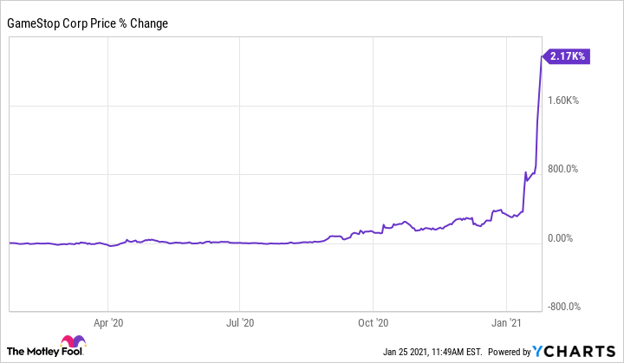

Figure

**The Players**

GameStop is an American high street shop that sells game, consoles, and other electronics. Founded in 1984 and headquartered in Grapevine, Texas, today GameStop is the kind of store found within a mall in between retail stores. Between 2004 and 2016, GameStop saw a lot of retail success, but starting from 2016 onward, the company began to decline rapidly in revenue. The major factors behind this decline can generally be attributed to the rise of online retail giant Amazon, horrendous return policies, a lackluster rewards program and controversy around work conditions and business practices. All of which left customers feeling undervalued and dissatisfied with the company. As of writing this paper the price per share currently sits between $100 – $200 depending on market volatility (BBC).

A hedge fund is an alternative investment vehicle that employs different strategies to earn active returns, or “alpha,” for their investors. A hedge fund is actually just a fancy name for an investment partnership that has freer rein to invest aggressively and in a wider variety of financial products than most mutual funds. In the last 20 years, the number of hedge funds have seen an exponential growth, and many have also been associated with several controversies. One aspect that has set the hedge fund industry apart is the fact that they face less regulation than mutual funds and other investment vehicles. Many of these hedge funds were shorting GameStop at 140% (The Balance).

A retail investor, commonly referred to as an individual investor, is a non-professional investor who typically conducts their transactions through a retail brokerage or platform they control themselves. Keith Gill is a retail investor who frequented the r/WallStreetBets subreddit, an online community of retail investors who gather to share and trade investing advice. Many of these retail investors operated through the do-it-yourself brokerage company Robinhood. It was this group of individuals who fueled what is known referred to as “The GameStop Short Squeeze,” ultimately, they are the ones who sit at the heart of this event (fool).

**What Even is a Stock?**

A stock is an investment, when an individual purchases a company’s stock, they are purchasing a small piece of ownership in that company, called a share. Stocks can only be issued by companies that decided to go “public,” private companies do not sell shares in their company. For companies that do decide to go public, issuing a stock is a way to raise money in order to grow and invest in additional capital. When an individual owns a stock in a company, they are called a shareholder because they retain the right to share in the company’s profits (called dividends). More specifically, for a retail investor, they would be called a “residual claimant,” meaning that they would have a claim on the companies’ residual profits, the remaining profit after all senior obligations are paid. If an individual own enough shares in a company, and receives enough votes at that companies’ shareholder meeting, then they retain the right to sit on that company’s board of directors. For shareholders, when a company does well, so do they, if they company does bad, they also will do bad, although, the liability of shareholders is limited. Stock’s carry more risk than other investments, but they also have the potential to reap higher rewards, making them an attractive investment opportunity, especially for retail investors. In the early 1600’s The Dutch East India Company was the first corporation to be listed on an official stock exchange (NerdWallet).

**The Market**

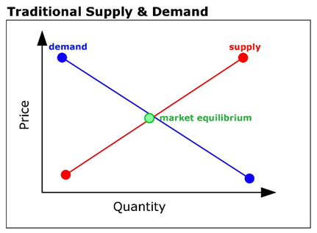Stocks, like all other goods and services, are typically bought and sold on markets known as stock markets. In the field of Economics, it is generally regarded that, like almost all products, the market is what ultimate determines stock prices as supply and demand change for that stock (see Figure 2). In Economics, the law of supply and demand is a theory that seeks to explain the relationship between the availability and desire for a product, such as a security, and its price. Typically, low availability and high demand boost the price of an item and high availability and low demand reduce its price. The law affects the stock market by determining the prices of the individual stocks that make up the market. What makes the stock market so unique is the fact that everybody play’s every role including, mutual fund managers, informed investors, uninformed investors, computers, etc. Additionally, it’s a commonly held belief that the stock market is “efficient,” since all market prices theoretically reflect all given knowledge available about the stock. This is commonly referred to as the Efficient Market Hypothesis. For example, the climb in GameStop’s value between late 2020 and early 2021 can be attributed to the news that Ryan Cohen had joined the company’s Board of Directors. In terms of the short squeeze, retail investors simply purchased enough stocks of the company to shift the demand curve dramatically to the right, resulting in the price of GameStop skyrocketing. So, when do stocks traditionally go up or down in price? In order to answer this question, one must look more closely at the present value of stocks (Investopedia – Supply and Demand).

Figure

**The Dividend Discount Model**

The dividend discount model (DDM) is a quantitative method used to predict the price of a company’s stock based on the theory that its stock present - day worth is the sum of all its future dividend payments, discounted back to their present value. The equation most widely used is commonly referred to as the *Gordon Growth Model (GGM)*, named after Myron J. Gordon, an American Economists, his work that led to the model borrowed heavily from “The Theory of Investment Value,” by John Burr Williams (Investopedia).

In order to understand the proof behind the DDM, it’s important to understand the concept that, within economics and finance, money has time value. A dollar today is worth more than a dollar tomorrow due to the investment capabilities that dollar possess through interest. Thus, the future value of an investment after one year can be represented as follows:

$$Future Value=Present Value*(1+i)$$

Where *i* represented the interest rate of that investment. This formula can then be rearranged to obtain the following formula for the present value of an invest after one year:

$$Present Value= \frac{Future Value}{(1+i)}$$

Using the present value formula, the dividend discount model can be derived from the following proposition: “suppose an investor buys a single share that they plan to sell in *n* year.” Since the DDM assumes that the value of a stock comes from the sum of its dividends and selling price, the fundamental value of the stock, *Pt*, can be represented as follows:

$$P_{t}={PV}_{t}=\left[PV of all dividends\right]+[PV of the selling price in n years]$$

$$= \frac{D_{1}}{{(1+i)}^{1}}+ \frac{D_{2}}{{(1+i)}^{2}}+ \frac{D_{3}}{{(1+i)}^{3}}+…+ \frac{D_{n}}{{\left(1+i\right)}^{n}}+ \frac{P_{sell (n)}}{{(1+i)}^{n}}$$

*Assumption 1*, dividends grow at a constant rate, g. Depending on this assumption, the model can vary in complexity. Different quantitative model’s assume different growth rates.

Let the dividends from years from now be represented as such:

$$D_{1}=D_{t}\left(1+g\right)$$

$$D_{2}=D_{1}\left(1+g\right)= D_{t}\left(1+g\right)\left(1+g\right)=D_{t}{\left(1+g\right)}^{2}$$

After *n* year:

$$D_{n}= D_{t}{(1+g)}^{n}$$

$$∴ P_{t }= \frac{D_{t }(1+g)}{(1+i)}+ \frac{D_{t }{(1+i)}^{2}}{{(1+i)}^{2}}+ \frac{D_{t }{(1+i)}^{3}}{{(1+i)}^{3}}+…+ \frac{D_{t }{\left(1+i\right)}^{n}}{{\left(1+i\right)}^{n}}+ \frac{P_{n}}{{(1+i)}^{n}}$$

*Assumption 2:* the stock is held for $n→ ∞$ years.

$$P_{t}= \sum_{j=1}^{n}{\frac{D_{t}{(1+g)}^{j}}{{(1+i)}^{j}}= D_{t}{\left(\frac{1+g}{1+i}\right)}^{j} }$$

Let $\frac{1+i}{1+g}=1+i^{*}→ \frac{1+g}{1+i}= \frac{1}{1+ i^{*}}$:

$$∴ P_{t }= \sum_{j=1}^{n}{\frac{D_{t}}{{(1+i^{*})}^{j}} }$$

Now expand:

$$P_{t }= \frac{D_{t }}{{(1+i^{*})}^{1}}+ \frac{D_{t }}{{(1+i^{*})}^{2}}+ \frac{D_{t }}{{(1+i^{*})}^{3}}+…+ \frac{D_{t }}{{(1+i^{*})}^{n}}$$

Multiply both sides by $\frac{1}{(1+ i^{*})}$:

$$\frac{P_{t}}{(1+ i^{*})}= \frac{D_{t }}{{(1+i^{*})}^{2}}+ \frac{D_{t }}{{(1+i^{*})}^{3}}+ \frac{D_{t }}{{(1+i^{*})}^{4}}+…+ \frac{D_{t }}{{(1+i^{*})}^{n + 1}}$$

Subtract the two models.

$$P_{t }- \frac{P_{t}}{\left(1+ i^{*}\right)}= \frac{D_{t }}{{\left(1+i^{*}\right)}^{1}}+ \frac{D_{t }}{{\left(1+i^{*}\right)}^{2}}+ \frac{D_{t }}{{\left(1+i^{*}\right)}^{3}}+…+ \frac{D_{t }}{{\left(1+i^{*}\right)}^{n}}-$$

$\frac{D_{t }}{{(1+i^{*})}^{2}}+ \frac{D_{t }}{{(1+i^{*})}^{3}}+ \frac{D_{t }}{{(1+i^{*})}^{4}}+…+ \frac{D_{t }}{{(1+i^{*})}^{n+1}}$

Which results in:

$$P_{t }- \frac{P_{t}}{\left(1+ i^{*}\right)}= \frac{D_{t }}{{\left(1+i^{*}\right)}^{1}}- \frac{D_{t }}{{(1+i^{*})}^{n+1}}$$

$$\frac{{(1+ i^{*})P}_{t}- P_{t}}{(1+ i^{*})}- \frac{P_{t}+ P_{t}i^{*}- P_{t}}{\left(1+ i^{*}\right)}= \frac{P_{t }i^{*}}{(1+ i^{*})}$$

$$\left(1+i^{*}\right)*\left( \frac{P_{t }i^{*}}{\left(1+ i^{*}\right)}\right)= \left(1+i^{*}\right)* \left(\frac{D_{t }}{{\left(1+i^{*}\right)}^{1}}- \frac{D_{t }}{{(1+i^{*})}^{n+1}}\right)$$

$$P_{t }i^{*}= D_{t }- \frac{D_{t }}{{\left(1+i^{*}\right)}^{n}}= D_{t }\left(1 - \frac{1}{{\left(1+i^{*}\right)}^{n}} \right)$$

$$P_{t }= \frac{D_{t}}{i^{*}}\left(1 - \frac{1}{{\left(1+i^{*}\right)}^{n}} \right)$$

Let $n→ ∞$:

$$P_{t }= \frac{D_{t}}{i^{*}}\left(1 - 0 \right)= \frac{D_{t}}{i^{*}}$$

Note: $\frac{1+i}{1+g}=1+i^{*}$

$$i^{*}= \frac{1+i}{1+g}- \frac{\left(1+g\right)}{\left(1+g\right)}= \frac{\left(1+i\right)-\left(1+g\right)}{\left(1+g\right)}=\frac{(i-g)}{(1+g)}$$

Now:

$$P_{t }= \frac{D_{t}}{i^{*}}= \frac{D_{t}(1+g)}{(i-g)}$$

Note: *i* is the first free return (rf) + risk premium (rp)

Finally:

$$P_{t }= \frac{D_{t}(1+g)}{(i-g)} = \frac{D_{t}(1+g)}{(rf+rp-g)} ∎$$

Consider the following statistical aphorism, “All models are wrong, but some are useful,” the dividend discount model is wrong, it will not tell you the price of a company with 100% accuracy. What it will tell you is that $P_{t }$ increases when dividends increase, the growth of dividends increase, or when the risk-free return and or the risk premium decrease. What’s so unique about the GameStop Short Squeeze is that its increase in price can not be tied to any components of the DDM, its dividends did not change (it’s a struggling business), nor did interest rates change. It also cannot be explained by the Efficient Market Hypothesis, simply put, the GameStop short squeeze was not rooted in economical or financial fundamentals.

**What is Shorting?**

For many of the billion-dollar hedge funds involved within the GameStop Short Squeeze, their involvement came from the fact that their “bet” on GameStop was to short it. Shorting is not difficult to understand, in fact, the mathematics behind shorting are rudimentary. When an individual thinks a company, they like is going to do good, they buy stock in that company with the hopes it will increase in value so that they can sell for a profit. This is referred to as going **long**, they buy low and sell high. The same goes for the inverse, they can sell high and then buy low, this is referred to as going **short.** If that same individual thinks a company is going to do bad, they can shortit. In order to understand shorting, it’s best to use an example. Euler Incorporation ($EI) is a struggling technology company, an investor, who has a feel that $EI’s next invention is going to flop decides to short 100 shares of the company. Through a miscellaneous brokerage service this investor decides to sell 100 shares at $10 per share (the market value), earning him $1,000 instantaneously. This investor also has to pay a small borrowing fee, which we will assume to be zero for this example and put down a deposit worth 150% of the financial transaction ($1,500), called a margin agreement. It’s important to note that this investor does *not* own these 100 shares, in fact, they belong to *someone* else entirely, while the brokerage service made the transaction near instantaneous, someone else’s share were sold by this investor. What this means is that this investor now owes 100 shares of $EI to some anonymous investor in *n* days. Where *n* is a mutually agreed upon number of days that these 100 shares are owed on.

After *n* days, the price of $EI has fallen to $2 a share, their recent invention was indeed a huge flop. This investor then enters into the market and buys 100 shares of $EI for a total cost of $200 dollars and returns those 100 shares to whomever they borrowed them from through their brokerage service, claiming their margin deposit in the process. This investor’s profit of their short position is now:

$1000 – $200 = $800

With their return on investment being:

$$\frac{800}{1000}*100=80\%$$

It’s important to note here that since stocks can never be priced at 0 dollars a share, it’s impossible to achieve a 100 percent return on investment when shorting, despite the potential for a stock to increase or decrease over 100 percent in value. Since shorting allows investors to sell stock they do not directly own, it make it possible for a situation called *naked shorting* to occur.

Naked shorting is the illegal practice of shorting shares that have not been affirmatively determined to exist. Usually, when an investor wants to short, brokerage services must determine if the stock they want to short can actually be borrowed before they can sell it (the float). Naked shorting simply refers to the short pressure placed on a stock that *potentially* may be larger than the number of tradable shores in the market. Naked shorting was made illegal after the 2008 financial crisis, but enough loopholes and discrepancies between electric and paper trading systems exist that allow for it to occur. At one point, prior to the squeeze, approximately 140 percent of GameStop shares were being short, allowing for the final condition for the short squeeze to occur (The Street).

**What is a short squeeze?**

Let’s now say that, instead, after the *n* days are up, $EI’s new invention was actually a huge success, resulting in the value of their stock to skyrocket. An investor who shorts, after whatever number of days, no matter what price, they *must* pay back the shares they owe. $EI’s stock has now shot up to $20 a share, a 100 percent increase in value, since there is no technical limit to how high a stock can increase in value, there’s no limit to how much an investor could lose when shorting. What’s worse is that that the act of buying shares in a company adds more demand for that stock, so for the investor who’s shorted $EI, their act of buying more shares results in the price per share to increase as well. The graph below model’s the economics of this outcome:

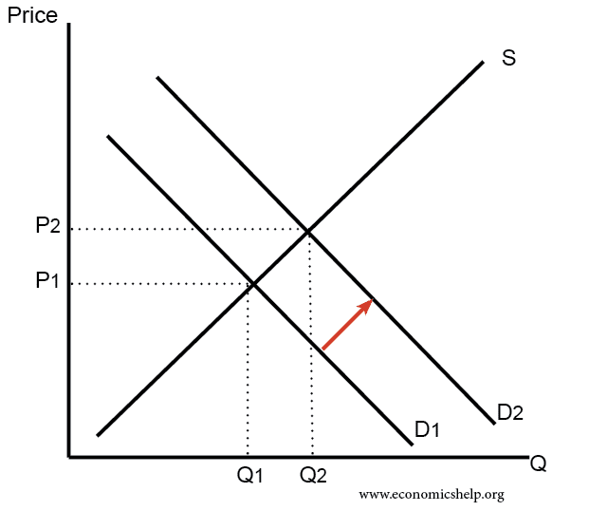

Figure

While the price per share of $EI might be $20 when this investor goes to buy, by the end of it, when they have finished purchasing the 100 shares they own, the price of the stock could have increased in the meantime, costing them and other investor’s more money. What’s worse, if the price per share gets high enough, the individual whom this investor borrowed from might **margin call** them. If the price of $EI goes above 50% of its original price ($10) – above $15 – then his investors original $1,500 deposit no longer cover’s their potential loses. This would result in the investor having to put down more money, this investor’s short position is now “squeezing” them out of money. The more $EI increases, the more this investor will get squeezed, if this continuous then they might even run out of money from all the margin calls. Their only choice by the end is to enter into the market and purchase these shares, which in turn adds to the demand for the stock and causes it to increase in price, resulting in more margin calls to occur. A financial short squeeze is much like an Ouroboros Snake, constantly feeding into itself and growing larger (see the image below), it will only end when the price of the company 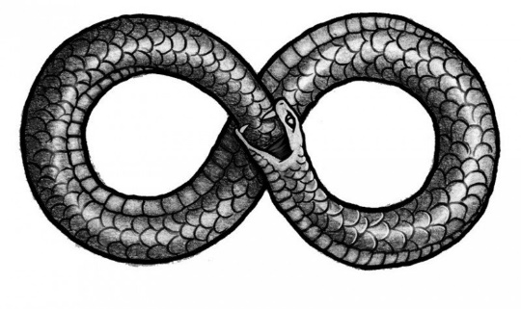stops increasing (bestinterest).

Figure

**The Case with GameStop:**

Described above is exactly what happened with GameStop, Hedge Funds such as Melvin and Citron, shorted GameStop. They borrowed, put down a deposit to cover potential losses through a margin requirement and sold their shares. The hopes of these hedge funds was to see GameStop’s price drop so that they could profit from it. It’s also important to note that Citron also planned to discuss *why* GameStop’s stock was overvalued in the first place, attempting to drive the company’s price down. It seems illegal, Hedge Fund’s shorting struggling businesses and then going into the market, publishing analyst reports on why these companies’ shares are overvalued and then profiting when these companies crash in value. None of this is illegal but this is where members of r/WallStreetBet’s took issue:

“If we all start buying tons of GameStop stock, we’ll drive the price way up! The billionaires will pay *tons* of margin calls. And then they’ll have to re-purchase the stocks — probably from us! — at huge prices. We’ll make money, and the billionaires will lose money!” (post by a user on r/WallStreetBet’s)

This is exactly what happened. Whatever their initial reasons, r/WallStreetBet’s accomplished exactly what they set off to do. By January 28th, Melvin Capital had already lost 30 percent of its value since the start of 2021, by the end of January a loss of 53% of its investments was suffered. Melvin ended January with $8 billons in assets, down from $12.5 billion at the start of the year. Andrew Left, head of Citron Research, who had also shorted GameStop, claimed the company had accrued a loss of 100% and announced it would discontinue shorting services after nearly 20 years of specializing in it. Both Melvin and Citron have both since closed their positions regarding GameStop and current analysis (as of the time of writing this paper) of the situation calculated losses on short positions in U.S. firms to be greater than $70 billion. Below is an illustration of the squeeze in action (Wikipedia).

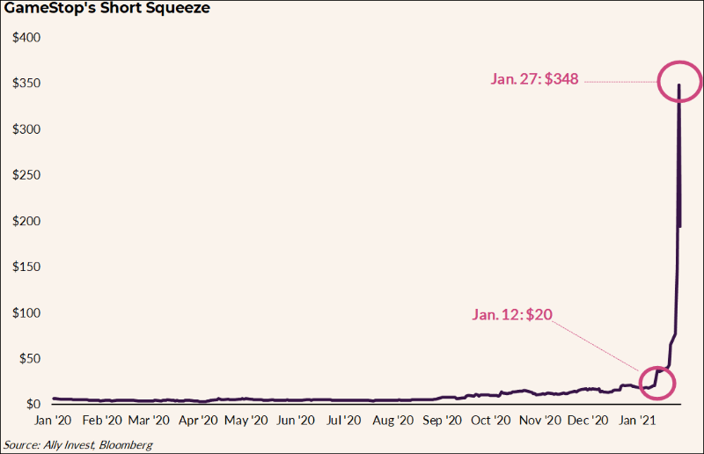

Figure

**The Case of the Options**

With nearly 70 billion dollars in losses many of these hedge funds, who wished to close their short positions, had to go, and purchase shares on the market. Many of these shares belonged to retail investors on r/WallStreetBets, allowing for them to reap large amounts of profit on their investments. Additionally, many users made huge amounts of money in the GameStop short squeeze through options and options trading. Options are financial derivatives that give buyers the right, but not the obligation, to buy or sell an underlying asset at an agreed-upon price and date (Investopedia). A Call Option is a contract between a seller (called the writer) and a buyer. The buyer has the right, but not the obligation, to buy from the seller (call for) a stock at a fixed price called the exercise or strike price. In a European call, the right to buy can only be exercised on the expiration date of the call. In an American call, the right to buy can be exercised at any time on or before the expiration date of the call.

For options on stocks, Call Options generally give the holder the right to buy 100 shares of a company at the strike price up until or on the expiration date depending on the call (American of European). The market price of a Call Option is called the premium, the price paid for the rights that the call option provides. If at the time of expiration, the asset is below the strike price, the call buyer losses the premium paid, the maximum loss. If it’s above, the profit is the current stock price minus the strike price and premium, multiplied by how many shares the option buyer controls and how many contracts they hold, this is referred to as being, “In the money.”

For example, consider a single American Call Option that gives a holder the right to buy 100 shares of $EI at $10 up until some expiratory date. If $EI is trading at $20 at the date of expiration, the strike price is $10, and the options cost the buyer $1, the profit is:

$20 – ($10 + $1) = $9

If the buyer bough one contract, that equates to $9 * 100 = $900 per contract. If at the date of expiration, the price of EI is below $10, then the option buyer loses $1 * 100 = $100 for each contract bought. Call Options are generally used to generate income, speculation, and tax management. Responsible short sellers use call options as a hedge (reduction in risk) against the trade falling apart on them. An investor who shorts 100 shares of EI at $10 a share might also buy the option to purchase 100 shares of $EI at $10 for $1 per contract. If EI were to run to $20 (rather than decrease), the trader can exercise the option and pay the lender back with the stock received on exercise.

Hedges eat into profits, so investors who short with conviction do not buy options to hedge, such was the case with GameStop. Retail investors on r/WallStreetBets realized this gamble (hedge funds were overplaying their hand) and jumped into the Options game in order to generate income on the potential squeeze by buying $GME call options. This gave them a stake in the squeeze and upward momentum of $GME without having to buy it out of the market. Consider the figure below detailing call options expiring on January 29th, 2021:

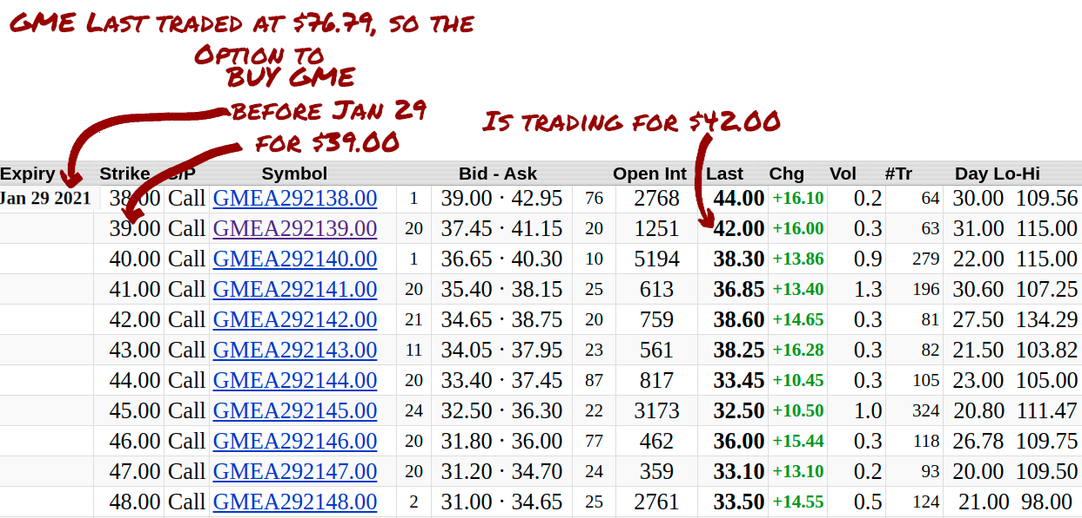

Figure

A retail investor on r/WallStreetBets will gamble on $GME continuing to go up and buy the call option in hopes that the shares of GME they purchased the right to buy will be worth more than the strike price of $39 before the contract’s expiration date. On January 25th, $GME was actively trading for $76.79, the $39 GME call option, was trading for $42, a cost of $3 per share for the call option, or $300 per contract. The profit per contract was as follows:

$76.79 – ($39 + $3) = $34.79 * 100 = $3,479

An individual who bought this option for $300 would have then seen a return on investment of:

$$\frac{34.79}{3}*100=1160\%$$

On January 28th, GME was trading for $193.60, the next day it was actively trading for $325 (thedeepdive).

**Conclusion (and the Role of Mathematics)**

On January 28th, some brokerages, including Robinhood, halted the buying of GameStop and other securities. The ethics of this decision are questionable, but this decision resulted in $GME crashing in value. By early February, $GME was floated at a price of around $50 a share. Keith Gill, who bet his life savings ($53,000) back on late 2020, who at the height of the short squeeze had assumed an investment worth close to $50 million (a 94339% return on investment), says he has no regrets about not liquidating all his assets. To him and many retail investors, the GameStop short squeeze was a shot at the elite. While many retail investors certainly garnered a profit, many did not and were left, “holding the bag.”

The GameStop short squeeze is ultimately a tale that will be told within the history book through numbers. The purpose of this paper was to show the kinds of stories that numbers can tell, both boring and unique. Mathematics is a tool that allows for individuals to cut through unnecessary information with the aim to get at the truth, to those that followed the numbers, like Keith Gills, so too did they reap great rewards. Economics and Finance thought, which up until now dictated much of the financial story, both failed to explain anything about this recent situation, mathematics has not. Moving forward its important for established investors to not forget where much of modern finances draws its roots from, mathematics, so that next time, hedge funds with decades worth of financial experience do not find themselves out 70 billion dollars, lost to some stranger behind a screen whose username is “Roaring Kitty.”

**Works Cited**

31, Jesse Cramer / January, et al. “The GameStop Short Squeeze Explained: 10 Questions and Answers.” *The Best Interest*, 5 Mar. 2021, bestinterest.blog/gamestop-short-squeeze/.

Braden MacckeBraden Maccke is a writer from British Columbia. “Gamestop: The GME Short Squeeze Explained.” *The Deep Dive*, 27 Jan. 2021, thedeepdive.ca/gamestop-the-gme-short-squeeze-explained/.

Chen, James. “How Options Work for Buyers and Sellers.” *Investopedia*, Investopedia, 2 Apr. 2021, www.investopedia.com/terms/o/option.asp.

Fernando, Jason. “Call Option.” *Investopedia*, Investopedia, 2 Apr. 2021, www.investopedia.com/terms/c/calloption.asp.

Grant, Kirsty. “GameStop: What Is It and Why Is It Trending?” *BBC News*, BBC, 28 Jan. 2021, www.bbc.com/news/newsbeat-55841719.

Investopedia. “How Does the Law of Supply and Demand Affect the Stock Market?” *Investopedia*, Investopedia, 28 Aug. 2020,

Kennon, Joshua. “What Is a Hedge Fund?” *The Balance*, www.thebalance.com/what-is-a-hedge-fund-357524.

Matt Frankel, CFP. “What Is a Retail Investor?” *Millionacres*, Millionacres, 4 Feb. 2021, www.fool.com/millionacres/real-estate-investing/commercial-real-estate/what-is-a-retail-investor/.

Mish. “Naked Shorting Is Illegal So How the Hell Was GameStop 140% Short.” *Mish Talk*, Mish Talk, 30 Jan. 2021, www.thestreet.com/mishtalk/economics/naked-shorting-is-illegal-so-how-was-gamestop-140-short.

Sonenshine, Jacob. *Options Helped Fuel the GameStop Stock Squeeze. Here's How That Works.*, Barrons, 28 Jan. 2021, www.barrons.com/articles/options-helped-fuel-the-gamestop-stock-squeeze-heres-how-that-works-51611872643.

Stewart, Emily. “The GameStop Stock Frenzy, Explained.” *Vox*, Vox, 25 Jan. 2021, www.vox.com/the-goods/22249458/gamestop-stock-wallstreetbets-reddit-citron.

Voigt, Kevin. “Definition: What Is Stock?” *NerdWallet*, 17 Mar. 2021, www.nerdwallet.com/article/investing/what-is-a-stock.